INDEX

* Acknowledgment…………………………………………………..2
* About the project…………………………………………………..3
* System Requirements………………………………………………4
* Flowchart……………...……………………………………………..5
* Design………………………………………………………………..12
* SQL Databases……………………………………………………..13
* Welcome…………………………………………………………….14
* Login and Sign Up………………………………………………….15
* Login…………………………………………………………………..16
* Sign Up………………………………………………………………..18
* Home……………………………………………………………….....20
* Soups and Salads…………………………………………………...22
* Drinks…………………………………………………………………..25
* Starters…………………………………………………………………28
* Main Course……………………………………………………….....30
* Desserts………………………………………………………………..33
* Cart…………………………………………………………………….35
* Payment Gateway………………………………………………….36
* My Orders……………………………………………………………..38

Acknowledgment

I would like to express my greatest gratitude to the people who have helped and supported me throughout my project. I am grateful to my teacher, Mrs. Vandana, for her continuous support for the project, from initial advice and conceptual inception and ongoing advice and encouragement to this day.

I want to thank my parents for their undivided support and interest, who inspired me & encouraged me to go my own way.

At last but not the least, a special thank of mine goes to my friends who helped me in completing the project. I want to thank my friends who appreciated me for my work and motivated me and finally to God who made all things possible.

About the project

The project (GUI Application) is designed for the use of customers to order food online. The main motive of the project is to allow customer to order food online without any hassle. The customer can order at will when they have time to. Also, the customer is able to customize their order without errors in communication between the customer and the person taking the order. In addition to customer advantages, the restaurant is able to take more orders with fewer staff. The restaurant does not need a waiter or hostess to be on the phone to take the order. The order can go straight to the kitchen, and thereafter delivered straight to the customers’ doorstep.

The project is designed in Netbeans™ IDE 8.0.2 and Adobe Photoshop, MS Paint have been used for editing and creating images. Other picture and backgrounds have been downloaded from http://[www.chew.net.in](http://www.chew.net.in) .

System Requirements

**Minimum Hardware Configurations**

* **Microsoft Windows XP Professional SP3/ Vista SP1/Windows 7 Professional:**

**Processer:** 800 MHz Intel Pentium III or equivalent **(Recommended 2.2 GHz)**

**Memory:** 512 MB **(Recommended 2 GB)**

**Disk Space:** 750 MB of free disk space **(Recommended 1.5 GB)**

* **Ubuntu 9.10:**

**Processer:** 800 MHz Intel Pentium III or equivalent **(Recommended 2.2 GHz)**

**Memory:** 512 MB  **(Recommended 2 GB)**

**Disk space:** 650 MB of free disk space **(Recommended 1.5 GB)**

* **Solaris OS version 11 Express(x86/x64 Platform Edition):**

**Processer:** AMD Opteron 1200 Series 1.8 GHz **(Recommended 2.8 GHz)**

**Memory:** 512 MB **(Recommended 2 GB)**

**Disk Space:** 750 MB of free disk space  **(Recommended 1.5 GB)**

* **Macintosh OS X 10.6 Intel:**

**Processer:** Dual-Core Intel (32 or 64-bit)

**Memory:** 1GB **(Recommended 2 GB)**

**Disk Space:** 750 MB of free disk space  **(Recommended 1.5 GB)**

Flowchart

**If choice =“LOGIN”**

**Accepts Required Information**

NO

**YES**

**ACCEPTS USERNAME AND PASSWORD**

**NO**

**Stores in Database**

**If Username=” “ and Password=” “**

**All Fields Entered Are Correct**

Add to Cart

Add to Cart

Add to Cart

**Accept Quantity**

**Accept Quantity**

**If Choice =**

**“Drinks”**

**NO**

**YES**

**If choice=**

**“Item 4”**

**If choice=**

**“Item 3”**

**If choice=**

**“Item 2”**

**If choice=**

**“Item 1”**

**NO NO NO**

**Accept Quantity**

**Accept Quantity**

**Entered**

**Entered**

**Entered**

**Entered**

**NO NO NO NO**

**YES**

**YES**

**YES**

**YES**

Add to Cart

Add to Cart

Add to Cart

Add to Cart

**Accept Quantity**

**Accept Quantity**

**If Choice =**

**“Soups”**

**NO**

**YES**

**If choice=**

**“Item 4”**

**If choice=**

**“Item 3”**

**If choice=**

**“Item 2”**

**If choice=**

**“Item 1”**

**NO NO NO**

**Accept Quantity**

**Accept Quantity**

**Entered**

**Entered**

**Entered**

**Entered**

**NO NO NO NO**

**YES**

**YES**

**YES**

**YES**

Add to Cart

Add to Cart

Add to Cart

Add to Cart

**Accept Quantity**

**Accept Quantity**

**If Choice =**

**“Starters”**

**NO**

**YES**

**If choice=**

**“Item 4”**

**If choice=**

**“Item 3”**

**If choice=**

**“Item 2”**

**If choice=**

**“Item 1”**

**NO NO NO**

**Accept Quantity**

**Accept Quantity**

**Entered**

**Entered**

**Entered**

**Entered**

**NO NO NO NO**

**YES**

**YES**

**YES**

**YES**

Add to Cart

Add to Cart

Add to Cart

Add to Cart

**Accept Quantity**

**Accept Quantity**

**If Choice =**

**“Main Course”**

**NO**

**YES**

**If choice=**

**“Item 1”**

**If choice=**

**“Item 1”**

**If choice=**

**“Item 2”**

**If choice=**

**“Item 1”**

**NO NO NO**

**Accept Quantity**

**Accept Quantity**

**Entered**

**Entered**

**Entered**

**Entered**

**NO NO NO NO**

**YES**

**YES**

**YES**

**YES**

Add to Cart

Add to Cart

Add to Cart

Add to Cart

**Accept Quantity**

**Accept Quantity**

**If Choice =**

**“Desserts”**

**NO**

**YES**

**If choice=**

**“Item 1”**

**If choice=**

**“Item 1”**

**If choice=**

**“Item 2”**

**If choice=**

**“Item 1”**

**NO NO NO**

**Accept Quantity**

**Accept Quantity**

**Entered**

**Entered**

**Entered**

**Entered**

**NO NO NO NO**

**YES**

**YES**

**YES**

**YES**

Add to Cart

**If Choice = “Order”**

**If Choice = “Sign Out**”

**Shows Final Amount**

**Proceed**

**Select payment mode**

**Order Confirmed**

DESIGN

There are a total of 12 main forms and 2 SQL database tables

1. Welcome
2. Login
3. Sign Up
4. Home
5. Drinks
6. Soups and Salads

Netbeans IDE Forms

1. Starters
2. Main Course
3. Deserts
4. Cart
5. Payment Gateway
6. Order Summary
7. User Information

SQL database table

1. Order

SQL DATABASE

The database is “CHEW” and contains two tables namely :

1. Users
2. Cart

Users table contains all the necessary information about the customers who use this app, whereas Cart table stores the food item details that have been added by the customer.The structure of both the tables have been described in the Fig (i) and Fig(ii).

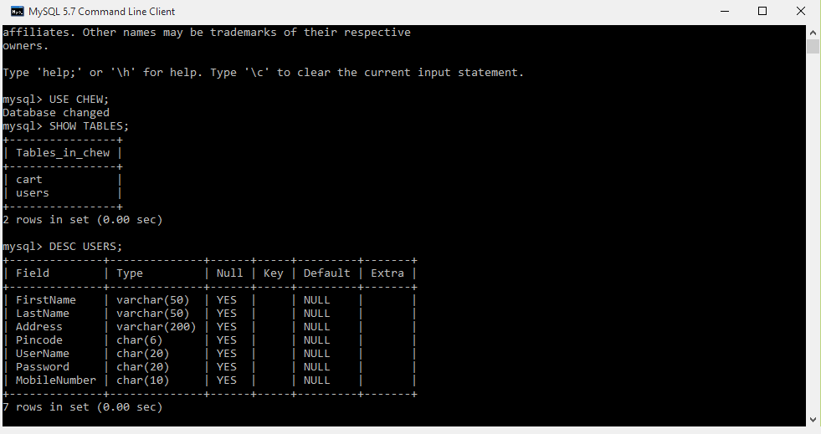

Fig (i)

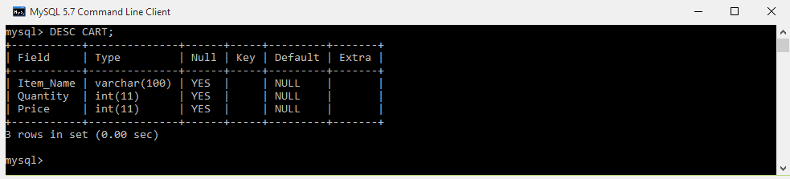

Fig(ii)

# ­Welcome

Design Preview:

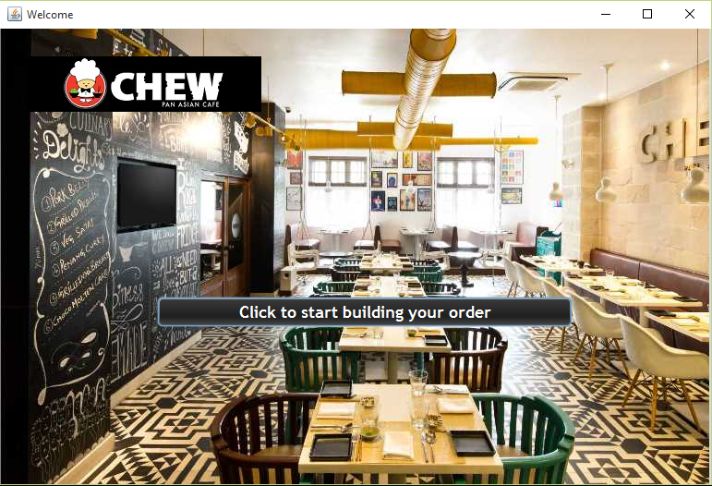

Source Code:

**private void jButton1ActionPerformed(java.awt.event.ActionEvent evt)**

**{**

this.setVisible(false);

new Login_SignUp().setVisible(true);

**}**

# Login and Sign Up

Design preview:



Source code:

**private void jButton1ActionPerformed(java.awt.event.ActionEvent evt)**

**{**

**this.setVisible(false);**

**new Login().setVisible(true);**

**}**

**private void jButton2ActionPerformed(java.awt.event.ActionEvent evt)**

**{**

**this.setVisible(false);**

**new SignUp().setVisible(true);**

**}**

# Login

DESIGN PREVIEW:

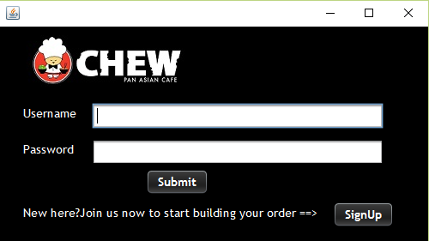

SOURCE CODE:

**private void jButton1ActionPerformed(java.awt.event.ActionEvent evt)**

**{**

String UserName=UserNamej.getText();

String Password=jPasswordField1.getText();

if(UserName.isEmpty())

{

JOptionPane.showMessageDialog(this,"Enter all fields");

UserNamej.setText("");

}

if(Password.isEmpty())

{

JOptionPane.showMessageDialog(this,"Enter all fields");

jPasswordField1.setText("");

}

else

{

try

{

Class.forName("java.sql.DriverManager");

Connection con = (Connection)

DriverManager.getConnection ("jdbc:mysql://localhost:3306/chew","root","apschool");

Statement stmt = (Statement) con.createStatement();

String query="SELECT FirstName,LastName,Address,Pincode,MobileNumber FROM Users WHERE Password='"+Password+"'AND UserName='"+UserName+"';";

ResultSet rs=stmt.executeQuery(query);

int Found=0;

while(rs.next())

// Till there are records in the result set

{

JOptionPane.showMessageDialog(null,"Login successful!!, click OK to continue");

Found++;

//Increment the variable to indicate a matching

//record has been found

}

if(Found>0)

{

this.setVisible(false);

new Home_Menu().setVisible(true);

}

else

{

UserNamej.setText("");

jPasswordField1.setText("");

JOptionPane.showMessageDialog(null,"No such User name and Password found, try logging in with a valid User name and Password ");

}

}

catch (Exception e)

{

JOptionPane.showMessageDialog(this, e.getMessage());

}

}

**}**

**private void jButton2ActionPerformed(java.awt.event.ActionEvent evt)**

**{**

this.setVisible(false);

new SignUp().setVisible(true);

**}**

# Sign Up

Design Preview:

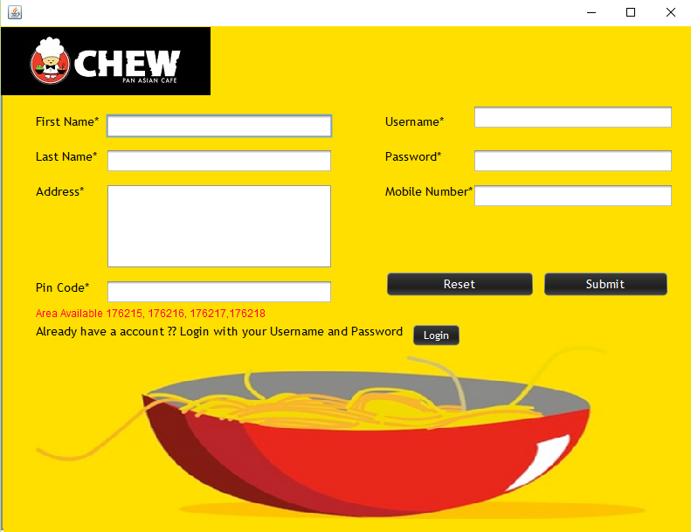

Source Code:

**private void jButton2ActionPerformed(java.awt.event.ActionEvent evt)**

**{**

String FirstName = jTextField1.getText();

String LastName = jTextField2.getText();

String Address = jTextArea1.getText();

String Pincode = jTextField3.getText();

String UserName = jTextField4.getText();

String Password = jPasswordField1.getText();

String MobileNumber = jTextField5.getText();

if(FirstName.isEmpty()||LastName.isEmpty()||Address.isEmpty()||Pincode.isEmpty()||UserName.isEmpty()||Password.isEmpty()||MobileNumber.isEmpty())

{

JOptionPane.showMessageDialog(this,"Enter all fields");

}

else

{

try

{

Class.forName("java.sql.DriverManager");

Connection con = (Connection) DriverManager.getConnection("jdbc:mysql://localhost:3306/chew", "root", "apschool");

Statement stmt = (Statement) con.createStatement();

String q = "SELECT *FROM users WHERE UserName='" + UserName + "';";

ResultSet rs = stmt.executeQuery(q);

if (rs.next())

{

JOptionPane.showMessageDialog(this, "This username exists ! Choose new Username");

jTextField4.setText("");

}

else

{

String query = "INSERT INTO users VALUES('" + FirstName + "','" + LastName + "','" + Address + "','" + Pincode + "','" + UserName + "','" + Password + "','" + MobileNumber + "');";

stmt.executeUpdate(query);

this.setVisible(false);

new Login().setVisible(true);

}

}

catch(Exception e)

{

JOptionPane.showMessageDialog(this, e.getMessage());

}

}

**}**

**private void jButton1ActionPerformed(java.awt.event.ActionEvent evt)**

**{**

jTextField1.setText("");jTextField2.setText("");

jTextField3.setText("");jTextField4.setText("");jTextField5.setText("");

jTextArea1.setText("");jPasswordField1.setText("");

**}**

**private void jButton4ActionPerformed(java.awt.event.ActionEvent evt)**

**{**

new Login_SignUp().setVisible(true);

this.setVisible(false);

**}**

# Home

Design Preview:

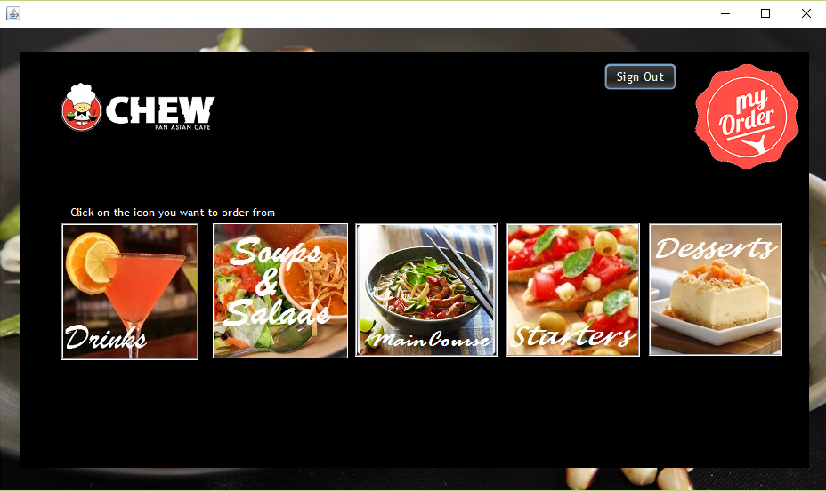

Source Code:

**private void jButton1ActionPerformed(java.awt.event.ActionEvent evt)**

**{**

this.setVisible(false);

new Drinks().setVisible(true);

**}**

**private void jButton3ActionPerformed(java.awt.event.ActionEvent evt)**

**{**

this.setVisible(false);

new Starters().setVisible(true);

**}**

**private void jButton2ActionPerformed(java.awt.event.ActionEvent evt)**

**{**

this.setVisible(false);

new Main_Course().setVisible(true);

**}**

**private void jButton4ActionPerformed(java.awt.event.ActionEvent evt)**

**{**

this.setVisible(false);

new Desserts().setVisible(true);

**}**

**private void jButton7ActionPerformed(java.awt.event.ActionEvent evt)**

**{**

new SoupsSalads().setVisible(true);

this.setVisible(false);

**}**

**private void jButton6ActionPerformed(java.awt.event.ActionEvent evt)**

**{**

try

{

Class.forName("java.sql.DriverManager");

Connection con = (Connection)

DriverManager.getConnection ("jdbc:mysql://localhost:3306/chew","root","apschool");

Statement stmt = (Statement) con.createStatement();

String query="TRUNCATE TABLE cart;";

stmt.executeUpdate(query);

JOptionPane.showMessageDialog(this,"SignOut successfull!");

this.setVisible(false);

new Welcome().setVisible(false);

}

catch(Exception e)

{JOptionPane.showMessageDialog (this, e.getMessage());

}

**}**

**private void jButton5ActionPerformed(java.awt.event.ActionEvent evt)**

**{**

this.setVisible(false);new Cart_1().setVisible(true);

try

{

Class.forName("java.sql.DriverManager");

Connection con = (Connection)

DriverManager.getConnection ("jdbc:mysql://localhost:3306/chew","root","apschool");

Statement stmt = (Statement) con.createStatement();

String query="SELECT SUM(Price) as Amount from cart;"

ResultSet rs=stmt.executeQuery(query);

if(rs.next())

{ String Amount= rs.getString("Amount"); Cart_1.jTextField1.setText(Amount); }

}catch(Exception e)

{ JOptionPane.showMessageDialog (this, e.getMessage()); }

**}**

# Soups

# Soups and Salads

Design Preview:

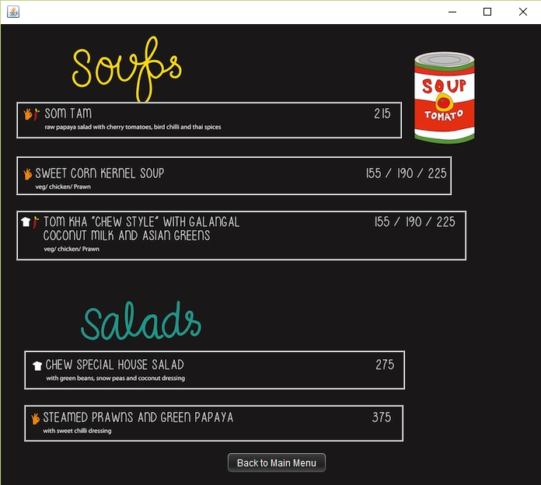

Source Code:

<Back to Main Menu Button>

**private void jButton6ActionPerformed(java.awt.event.ActionEvent evt)**

**{**

new Home_Menu().setVisible(true);

this.setVisible(false);

**}**

When any of the food item button is clicked the following window containing the respective food item name opens:

Design Preview:

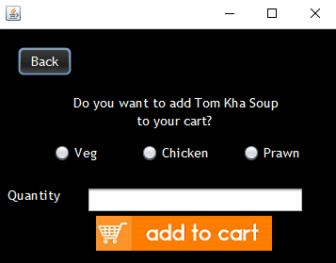

Source Code:

**private void jButton2ActionPerformed(java.awt.event.ActionEvent evt)**

**{**

int Quantity=Integer.parseInt(jTextField1.getText());

String quan=jTextField1.getText();

if(jRadioButton1.isSelected())

{

jRadioButton2.setSelected(false);jRadioButton3.setSelected(false);

int Price=155*Quantity;

String Item_Name="Tom Kha Veg";

try

{

Class.forName("java.sql.DriverManager");

Connection con = (Connection)

DriverManager.getConnection ("jdbc:mysql://localhost:3306/chew","root","apschool");

Statement stmt = (Statement) con.createStatement();

String query="INSERT INTO CART VALUES('"+Item_Name+"','"+Quantity+"','"+Price+"');";

stmt.executeUpdate(query);

JOptionPane.showMessageDialog(this,"Item added successfully to your cart!");

}

catch(Exception e)

{

JOptionPane.showMessageDialog (this, e.getMessage());

}

}

else if(jRadioButton2.isSelected())

{

jRadioButton1.setSelected(false);jRadioButton3.setSelected(false);

int Price=190*Quantity;

String Item_Name="Tom Kha Chicken";

try

{

Class.forName("java.sql.DriverManager");

Connection con = (Connection)

DriverManager.getConnection ("jdbc:mysql://localhost:3306/chew","root","apschool");

Statement stmt = (Statement) con.createStatement();

String query="INSERT INTO CART VALUES('"+Item_Name+"','"+Quantity+"','"+Price+"');";

stmt.executeUpdate(query);

JOptionPane.showMessageDialog(this,"Item added successfully to your cart!");

}

catch(Exception e)

{

JOptionPane.showMessageDialog (this, e.getMessage());

}

}

else if(jRadioButton3.isSelected())

{

jRadioButton2.setSelected(false);jRadioButton1.setSelected(false);

int Price=225*Quantity;

String Item_Name="Tom Kha Prawn";

try

{

Class.forName("java.sql.DriverManager");

Connection con = (Connection)

DriverManager.getConnection ("jdbc:mysql://localhost:3306/chew","root","apschool");

Statement stmt = (Statement) con.createStatement();

String query="INSERT INTO CART VALUES('"+Item_Name+"','"+Quantity+"','"+Price+"');";

stmt.executeUpdate(query);

JOptionPane.showMessageDialog(this,"Item added successfully to your cart!");

}

catch(Exception e)

{

JOptionPane.showMessageDialog (this, e.getMessage());

}

}

else

JOptionPane.showMessageDialog (this,"Enter all fields");

**}**

**private void jButton1ActionPerformed(java.awt.event.ActionEvent evt)**

**{**

new SoupsSalads().setVisible(true);this.setVisible(false);

**}**

# Driinks

# Drinks

Design Preview:

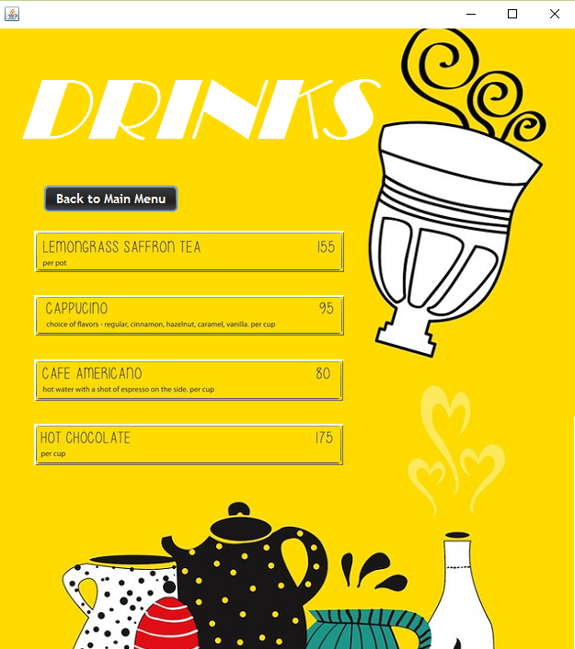

Source Code

<Back to Main Menu button>

**private void jButton5ActionPerformed(java.awt.event.ActionEvent evt)**

**{**

this.setVisible(false);

new Home_Menu().setVisible(true);

**}**

When any of the food item button is clicked the following window containing the respective food item name opens:

Design Preview:

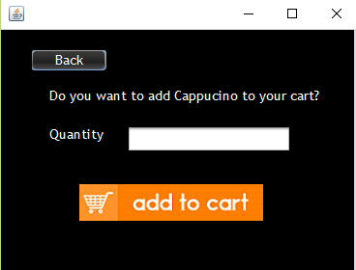

Source Code:

**private void jButton1ActionPerformed(java.awt.event.ActionEvent evt)**

**{**

int Quantity=Integer.parseInt(jTextField1.getText());

String quan=jTextField1.getText();

int Price=95*Quantity;

String Item_Name="Cappucino";

if(quan.isEmpty())

{

JOptionPane .showMessageDialog(this,"Item not added to cart!");

}

else

{

try

{

Class.forName("java.sql.DriverManager");

Connection con = (Connection)

DriverManager.getConnection ("jdbc:mysql://localhost:3306/chew","root","apschool");

Statement stmt = (Statement) con.createStatement();

String query="INSERT INTO CART VALUES('"+Item_Name+"','"+Quantity+"','"+Price+"');";

stmt.executeUpdate(query);

JOptionPane.showMessageDialog(this,"Item added successfully to your cart!");

}

catch(Exception e)

{

JOptionPane.showMessageDialog (this, e.getMessage());

}

}

**}**

**private void jButton2ActionPerformed(java.awt.event.ActionEvent evt)**

**{**

this.setVisible(false);

new Drinks().setVisible(true);

**}**

# Starters

Design Preview:

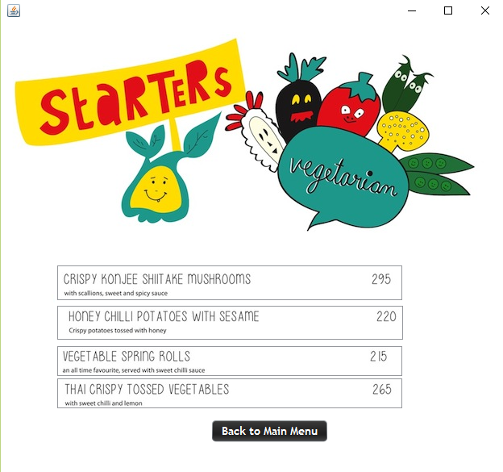

Source Code:

<Back to Main Menu button>

**private void jButton5ActionPerformed(java.awt.event.ActionEvent evt)**

**{**

this.setVisible(false); new Home_Menu().setVisible(true);

**}**

When any of the food item button is clicked the following window containing the respective food item name opens:

Design Preview:

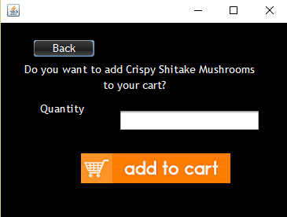

Source Code:

**private void jButton1ActionPerformed(java.awt.event.ActionEvent evt)**

**{**

int Quantity=Integer.parseInt(jTextField1.getText()); String quan=jTextField1.getText();

int Price=295*Quantity; String Item_Name="Crispy Shitake Mushrooms";

if(quan.isEmpty())

{

JOptionPane .showMessageDialog(this,"Item not added to cart!");

}

else

{

try

{

Class.forName("java.sql.DriverManager");Connection con = (Connection)

DriverManager.getConnection ("jdbc:mysql://localhost:3306/chew","root","apschool");

Statement stmt = (Statement) con.createStatement();

String query="INSERT INTO CART VALUES('"+Item_Name+"','"+Quantity+"','"+Price+"');";

stmt.executeUpdate(query);

JOptionPane.showMessageDialog(this,"Item added successfully to your cart!");

}

catch(Exception e)

{ JOptionPane.showMessageDialog (this, e.getMessage());

}}

**}**

# Main

# Main Course

Design Preview:

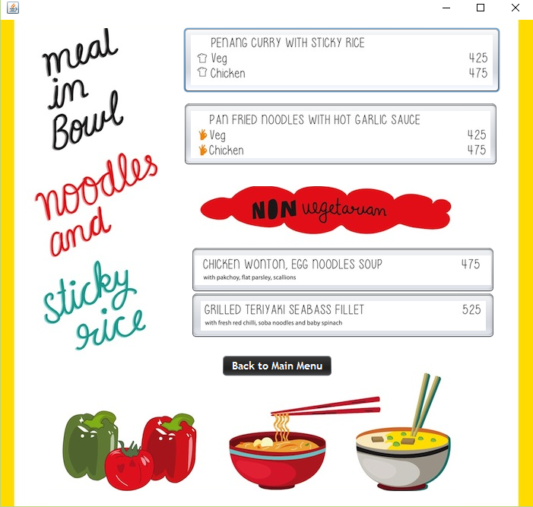

Source Code:

<Back to Main Menu button>

**private void jButton5ActionPerformed(java.awt.event.ActionEvent evt)**

**{**

this.setVisible(false); new Home_Menu().setVisible(true);

**}**

When any of the food item button is clicked the following window containing the respective food item name opens:

Design Preview:

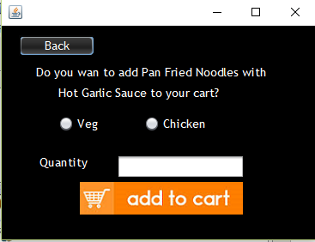

Source Code:

**private void jButton2ActionPerformed(java.awt.event.ActionEvent evt)**

**{**

int Quantity=Integer.parseInt(jTextField1.getText());

String quan=jTextField1.getText();

if(jRadioButton1.isSelected())

{

int Price=425*Quantity;

String Item_Name="Pan Fried Noodles Veg";

try

{

Class.forName("java.sql.DriverManager");

Connection con = (Connection)

DriverManager.getConnection ("jdbc:mysql://localhost:3306/chew","root","apschool");

Statement stmt = (Statement) con.createStatement();

String query="INSERT INTO CART VALUES('"+Item_Name+"','"+Quantity+"','"+Price+"');";

stmt.executeUpdate(query);

JOptionPane.showMessageDialog(this,"Item added successfully to your cart!");

}

catch(Exception e)

{

JOptionPane.showMessageDialog (this, e.getMessage());

}

}

else if(jRadioButton2.isSelected())

{

int Price=475*Quantity;

String Item_Name="Pan Fried Noodles Non-Veg";

try

{

Class.forName("java.sql.DriverManager");

Connection con = (Connection)

DriverManager.getConnection ("jdbc:mysql://localhost:3306/chew","root","apschool");

Statement stmt = (Statement) con.createStatement();

String query="INSERT INTO CART VALUES('"+Item_Name+"','"+Quantity+"','"+Price+"');";

stmt.executeUpdate(query);

JOptionPane.showMessageDialog(this,"Item added successfully to your cart!");

}

catch(Exception e)

{

JOptionPane.showMessageDialog (this, e.getMessage());

}

}

else

JOptionPane.showMessageDialog (this,"Enter all fields");

**}**

**private void jButton1ActionPerformed(java.awt.event.ActionEvent evt)**

**{**

this.setVisible(false);

new Main_Course().setVisible(true);

**}**

# Desserts

Design Preview:

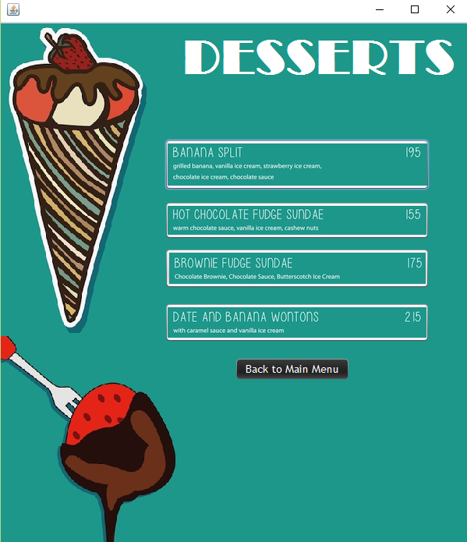

Source Code:

<Back to Main Menu button>

**private void jButton5ActionPerformed(java.awt.event.ActionEvent evt)**

**{**

this.setVisible(false); new Home_Menu().setVisible(true);

**}**

When any of the food item button is clicked the following window containing the respective food item name opens:

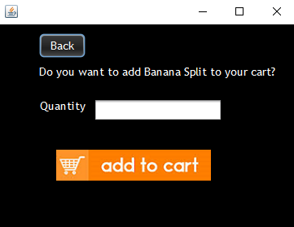

Source Code:

**private void jButton1ActionPerformed(java.awt.event.ActionEvent evt)**

**{**

int Quantity=Integer.parseInt(jTextField1.getText()); String quan=jTextField1.getText();

int Price=195*Quantity; String Item_Name="Banana Split";

if(quan.isEmpty())

{JOptionPane .showMessageDialog(this,"Item not added to cart!"); }

else

{try

{

Class.forName("java.sql.DriverManager");Connection con = (Connection)

DriverManager.getConnection ("jdbc:mysql://localhost:3306/chew","root","apschool");

Statement stmt = (Statement) con.createStatement();

String query="INSERT INTO CART VALUES('"+Item_Name+"','"+Quantity+"','"+Price+"');";

stmt.executeUpdate(query);

JOptionPane.showMessageDialog(this,"Item added successfully to your cart!");

}

catch(Exception e)

{JOptionPane.showMessageDialog (this, e.getMessage());

} }

**}**

# Cart

Design Preview:

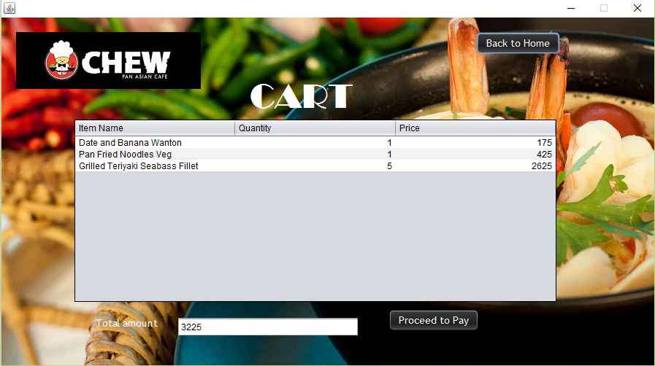

Source Code:

**private void jButton2ActionPerformed(java.awt.event.ActionEvent evt)**

**{**

this.setVisible(false);new Payment_Gateway().setVisible(true);

try

{

Class.forName("java.sql.DriverManager");

Connection con = (Connection)

DriverManager.getConnection ("jdbc:mysql://localhost:3306/chew","root","apschool");

Statement stmt = (Statement) con.createStatement();

String query="SELECT SUM(Price) as Amount from cart;"

ResultSet rs=stmt.executeQuery(query);

if(rs.next())

{

Amount= rs.getString("Amount")Payment_Gateway.jTextField1.setText(Amount);}

}

catch(Exception e)

{

JOptionPane.showMessageDialog (this, e.getMessage());

}

**}**

# Payment Gateway

Design Preview:

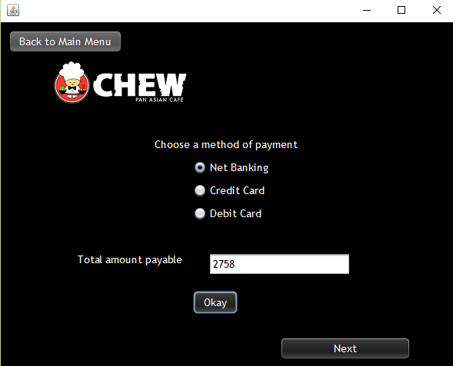

Source Code:

**private void jButton1ActionPerformed(java.awt.event.ActionEvent evt)**

**{**

int pay=Integer.parseInt(jTextField1.getText());

if(jRadioButton1.isSelected())

{

jRadioButton2.setSelected(false);jRadioButton3.setSelected(false);

jTextField1.setText(Integer.toString(pay-((10*pay)/100)));

jButton4.setEnabled(true);

}

if(jRadioButton2.isSelected())

{

jRadioButton1.setSelected(false);jRadioButton3.setSelected(false);

jTextField1.setText(Integer.toString(pay-((5*pay)/100)));

jButton4.setEnabled(true);

}

if(jRadioButton3.isSelected())

{

jRadioButton2.setSelected(false);jRadioButton1.setSelected(false);

jTextField1.setText(Integer.toString(pay-((6*pay)/100)));

jButton4.setEnabled(true);

}

JOptionPane.showMessageDialog(this,"Click next for your order summary");

**}**

**private void jButton4ActionPerformed(java.awt.event.ActionEvent evt)**

**{**

this.setVisible(false);

new OrderSummary().setVisible(true);

try

{

OrderSummary.jTextField4.setText("30 minutes from now");

int NewAmount=Integer.parseInt(jTextField1.getText());

OrderSummary.jTextField3.setText(Integer.toString(NewAmount));

}

catch(Exception e)

{

JOptionPane.showMessageDialog (this, e.getMessage());

}

**}**

# Order Summary

Design Preview:

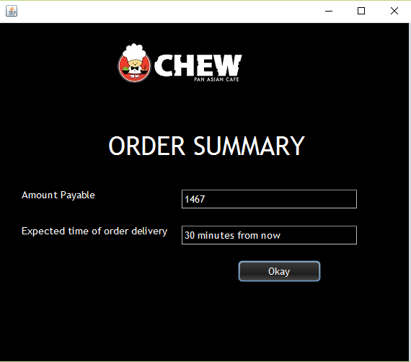

Source Code:

**private void jButton1ActionPerformed(java.awt.event.ActionEvent evt)**

**{**

JOptionPane.showMessageDialog(this,"Thank you for ordering! Have a nice day!");

System.exit(0);

**}**